Self-Directed Activities: Picoboard

Activity 1 - Use the Picoboard

Note - for this activity, you will need to use the offline version of Scratch (Scratch 1.4).

The picoboard is a sensor board, which enables Scratch to respond to events happening outside of the computer via the different sensors:

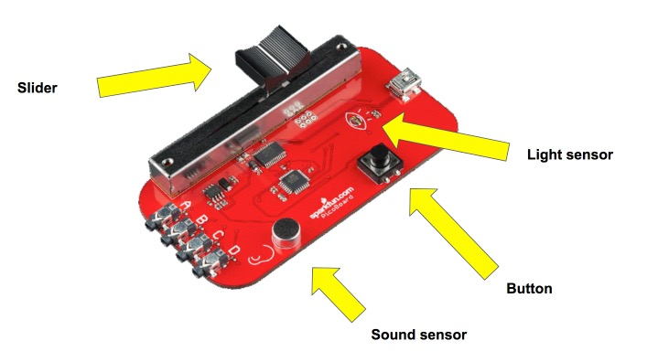
Begin by connecting the picoboard to the computer via the orange USB cable.

Once connected, you will create a simple event in Scratch using the picoboard. From the Sensing palette, begin by dragging over the block, ‘slider sensor value’. When the slider is moved on the Picoboard, the sprite on the screen should move as well. To do this, you need to put the ‘slider sensor value’ block inside a greater than (>) block. The final block of code should look like this:

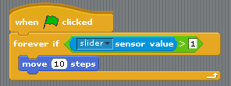

Observe how when the slider is moved, the sprite moves across the screen. Ask: how can we make sure that the sprite returns to its original place?

In order for the sprite to move back to its original place, you need to create a new block of code that says ‘forever if slider sensor value’ = 0 to go to these specific coordinates.

The block of code should look something like this:

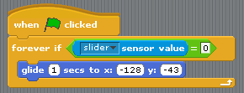

Try several different inputs from the Picoboard (sound, button pressed, light). Remember, the button, slider, light sensor and sound sensor are all examples of inputs; the output is what happens to the sprite as a result of the input.

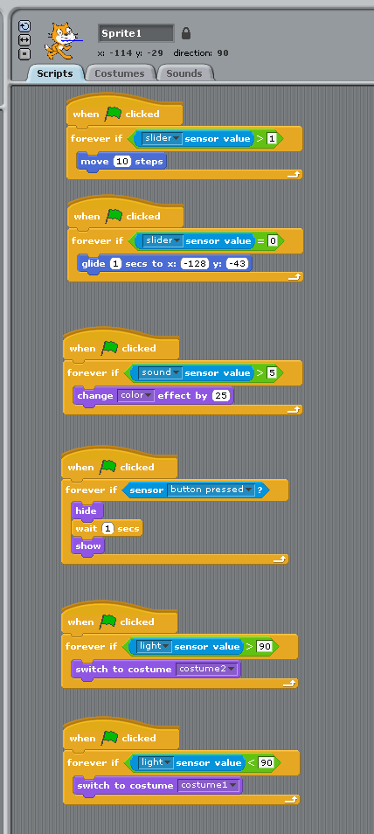

Activity 2 - Create a new Scratch program (using Scratch 1.4), with interesting sprites that respond to all four of the picoboard’s inputs: light, sound, the button and the slider.

