Self-Directed Activities: Photo Editing

These activities require PhotoPlus software to be installed, but all photo editing software will have fairly similar features.

Activity 1 - Crop a digital photo

Cropping is a technique used to remove unwanted parts of photos. The user highlights the part of the photo they want to keep and the rest of the photo is deleted. If used well, cropping can often improve photos.

- Cropping can be used to focus on the subject of the photo and correct any framing mistakes. Click on the Crop Tools icon and use the mouse to drag a rectangle over the desired area of the photo for cropping:
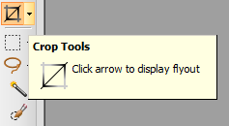

When this is done, double click on the desired area to crop the photo.
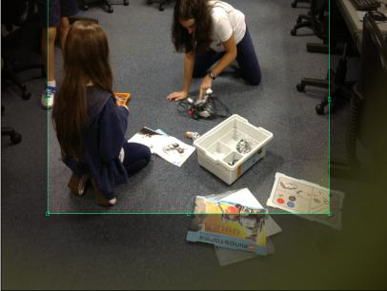
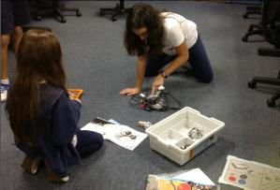

Using the rule of thirds, we can imagine that our photo is split into thirds. When you crop the photo, place the focal point (in this case, the boy at the front) where the grid lines cross.

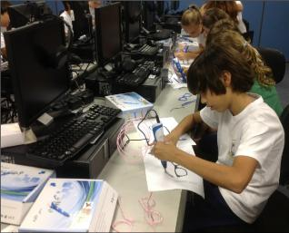
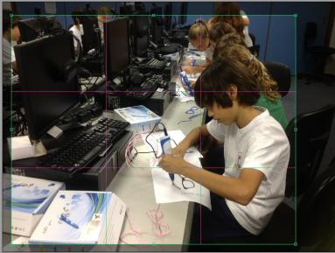

2. The QuickShape Selection Tool allows you to select a range of different shapes in which to crop photos.
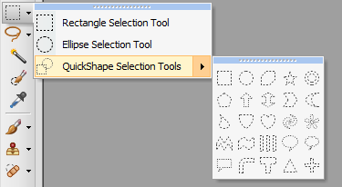

When this method is chosen and the area is selected, you need to double click on the area, then right click and select ‘Crop to selection’.

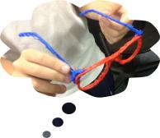
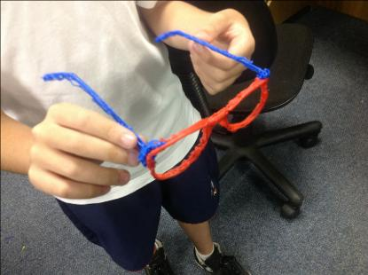

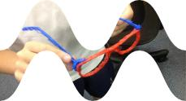

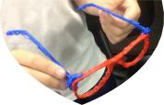

The pixabay website also contains plenty of images that do not have a copyright licence and are therefore free to use or share.

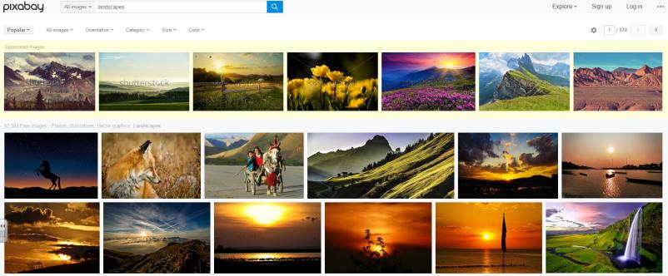

When the chosen image is found, right click on the image and click ‘Copy image’.

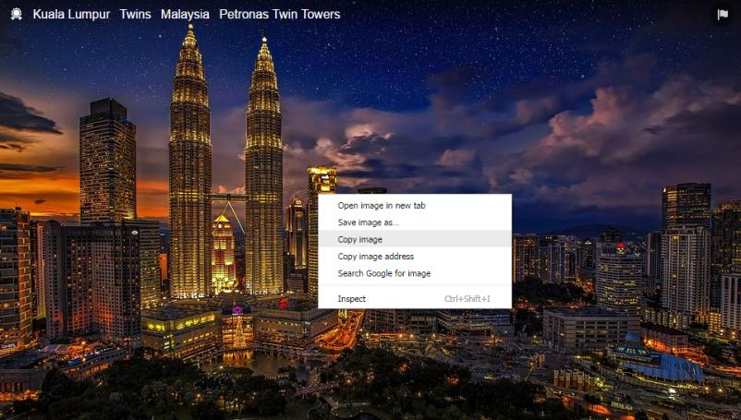

Then from PhotoPlus, click Edit > Paste > As New Image.

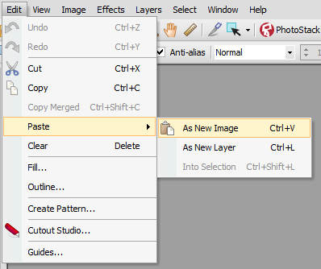

Activity 2 - Use the PhotoFix feature

One of the built-in features of PhotoPlus is PhotoFix. This feature allows users to create different versions of their photographs.

Some examples of what this feature does:

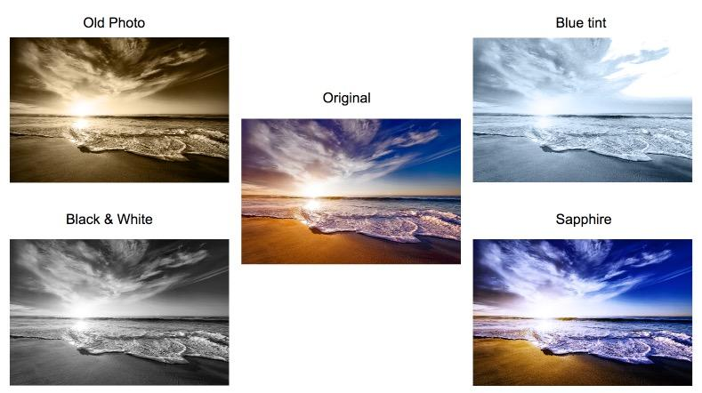

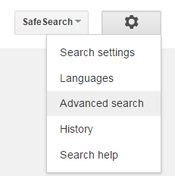
Use Google Advanced Image Search in order to find an image of a landscape that has a minimum size of 800 x 600 and is free to use and share:

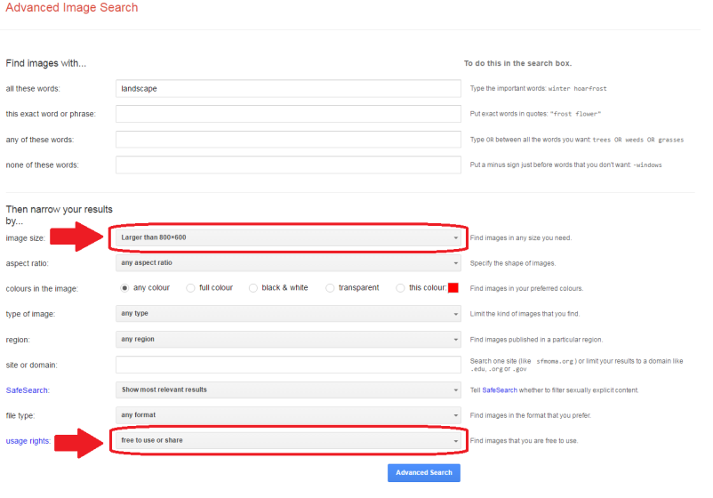
(Alternatively, you can just get the students to use the Pixabay website again.)

Once you have chosen an image, copy it. Open up PhotoPlus > select Paste > As New Image.

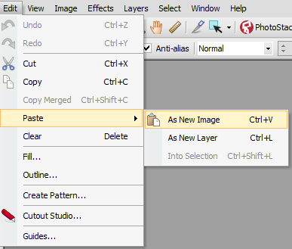

Experiment using the PhotoFix on their photo:

Activity 3 - Use Filter Effects Feature

You can completely change a photo’s appearance by using the Filter Effects Feature. In order to apply a filter to a photograph, simply: 1. click Filter Gallery > 2. select the desired filter.

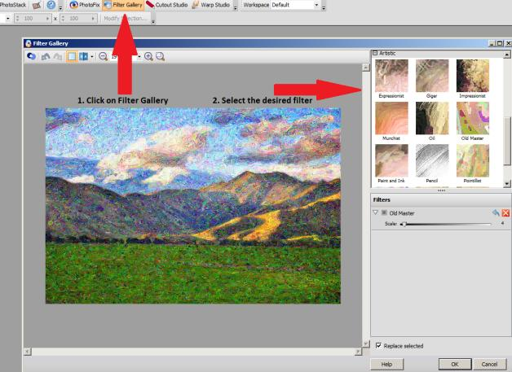

Activity 4 - Edit groups of pixels

Images are made up of thousands of pixels. A pixel is the smallest element of an image that we can edit. If we select groups of pixels therefore, we can edit smaller parts of a photo separately.

By using the Magic Wand Tool and clicking on a picture, we can select whole areas of a photo. In this activity, practise using the Magic Wand Tool.

Try to follow similar steps for your image:

- Removing the sky:
- First, convert the background to a layer. Right click on the Background in the Layers tab, select Promote to Layer and click OK.
- Next, click on the wand tool and set the tools options as shown:
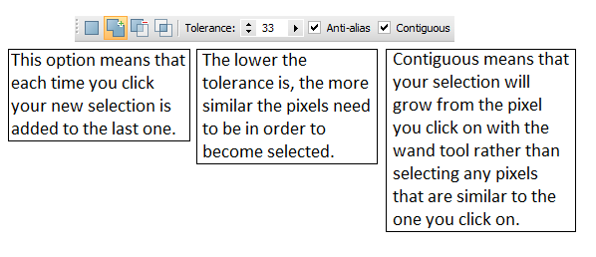
- Then, click on the bottom of the sky. Keep clicking on deselected areas until the whole sky is selected.
- Finally, select Edit and then Cut.

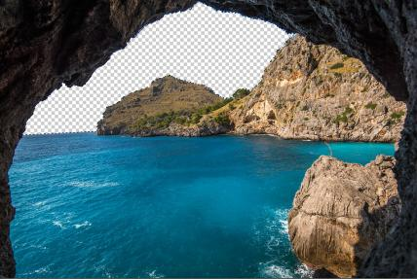
2. Colouring the sky:
- Once the sky is deleted, right click on the selection and click Deselect.
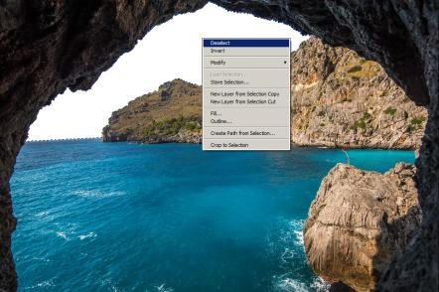
- Click on the Flood Fill Tool , select the desired colour and click in the area where the sky should be.

3. Colouring the sea:
- Follow the previous steps for removing the sky and colouring the sky in order to be able to colour the sea.
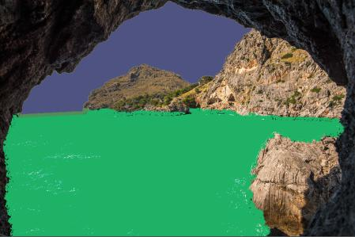

Activity 5 - Use the Clone Tool

In digital photo editing, cloning means copying pixels.
The clone brush allows you to select part of a photo and then use this as a paint brush on another area. If used carefully, this tool allows you to improve the quality of your photo by removing imperfections.

The Clone tool was used to create a ‘Spot the difference’ puzzle below:
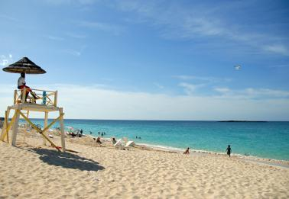
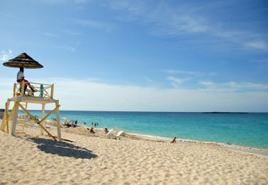
Step 1 - Click on the clone tool and make the following changes to the menu options below:

Step 2 - Move the cursor over the area that you want to copy and press down the Alt key. Use short drags and mouse clicks over the area you are changing until the colours have been blended in.

Using the Clone tool, experiment with creating your own Spot the difference puzzle on a new Google Slide.

