Self-Directed Activities: Minecraft

This handout provides information, instructions and ideas for both teachers and students. Before students can begin with this activity, the teacher must create a New World, following the instructions below:

Activity - Use Minecraft to create a city

Teacher Instructions for Opening Minecraft:

Step 1.

Open the Minecraft Server Tool on the teacher computer and select ‘Start MinecraftEdu Server Launcher':

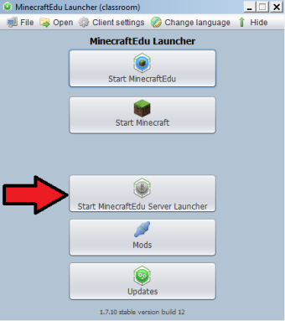

Step 2.

Click ‘Create New World’.

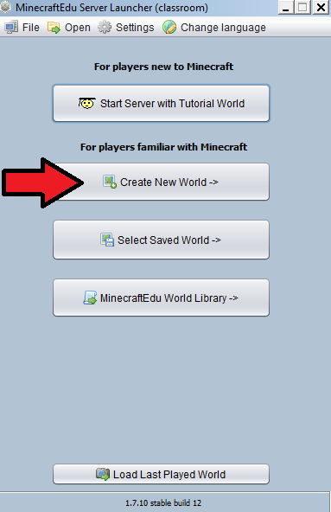
Step 3.

Select the option to ‘Generate a Completely Flat World’.

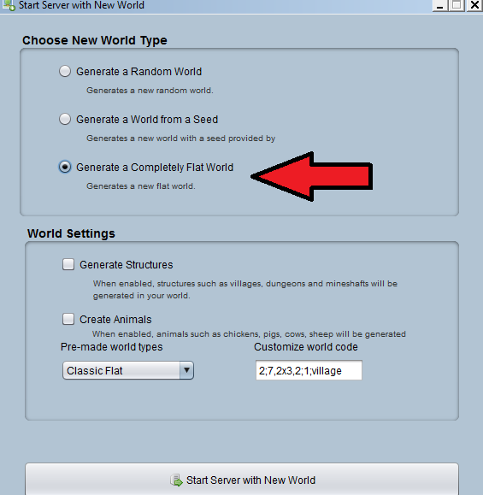

Step 4.

Write the Server number on the whiteboard. (Students will need this for later.) Then, from the World Settings tab, make sure the game mode is set to ‘Creative’. In creative mode, students have all the building blocks available that they will need to build.

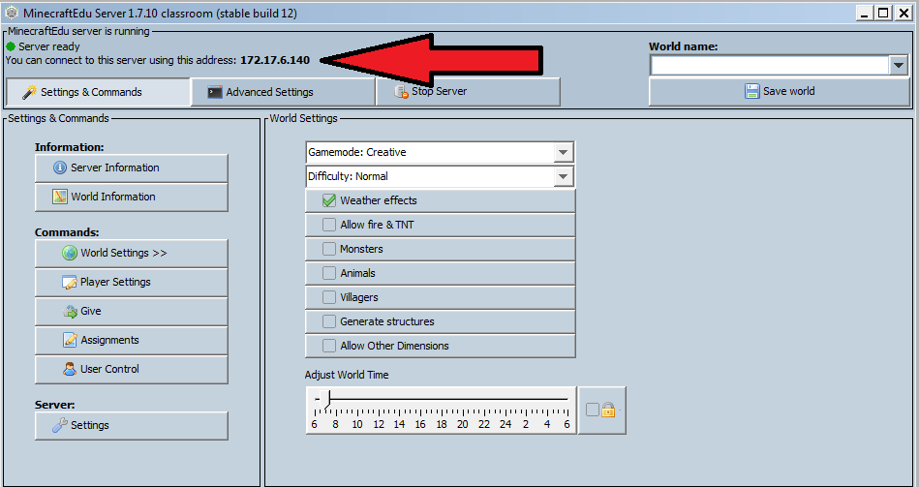

Step 5.

Next, make sure that you set a teacher password, e.g. British123. (You will use this to enter the Minecraft the world as a teacher.)

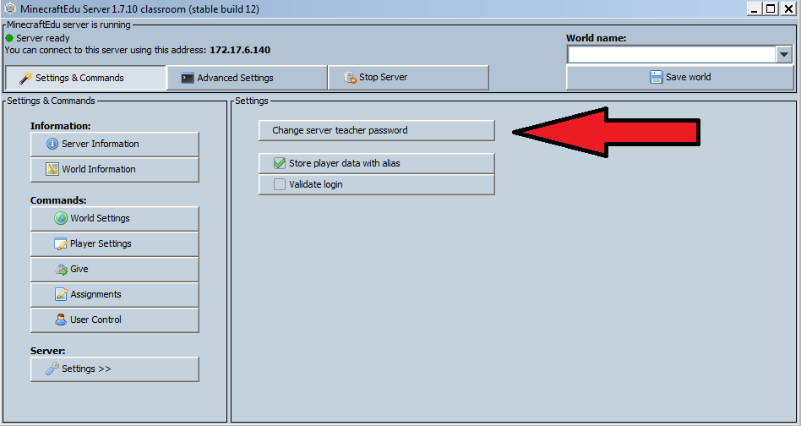

Step 6.

Before students begin using Minecraft, make sure that you divide them into five teams:

Commercial | Industrial | Municipal | Public Services | Residential

Remind students of the different buildings associated with each category. Students in each of these construction teams will be making buildings appropriate to their category, e.g. students in the Commercial construction team will build shops, restaurants, etc.

Student Instructions for Opening Minecraft:

Step 1. Open up Minecraft from the Start menu and select ‘Start MinecraftEdu’.

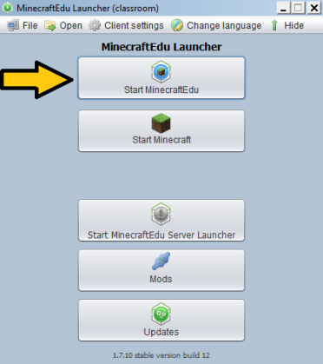

Step 2. Choose your player name (this should be your real name, so that your teacher can identify you in the Minecraft world) and select whether you are male or female.

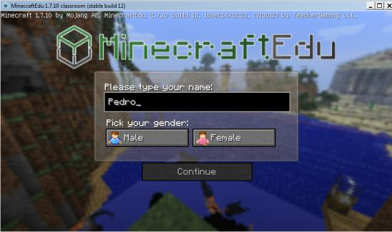

Step 3. Select ‘Multiplayer’.

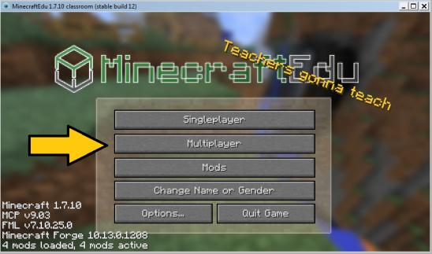

Step 4. Click ‘Direct Connect’.

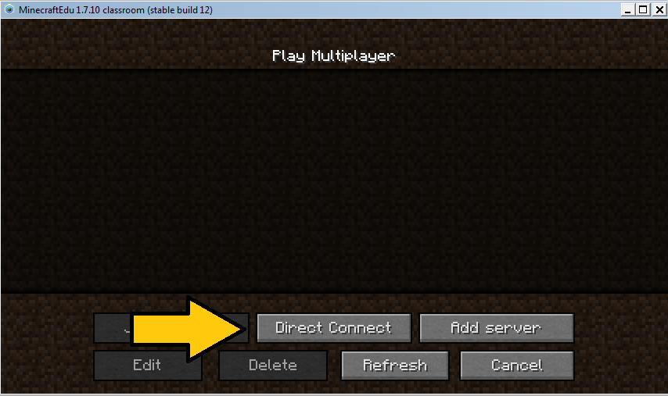
Step 5. Type in the Server number that your teacher has written on the whiteboard.

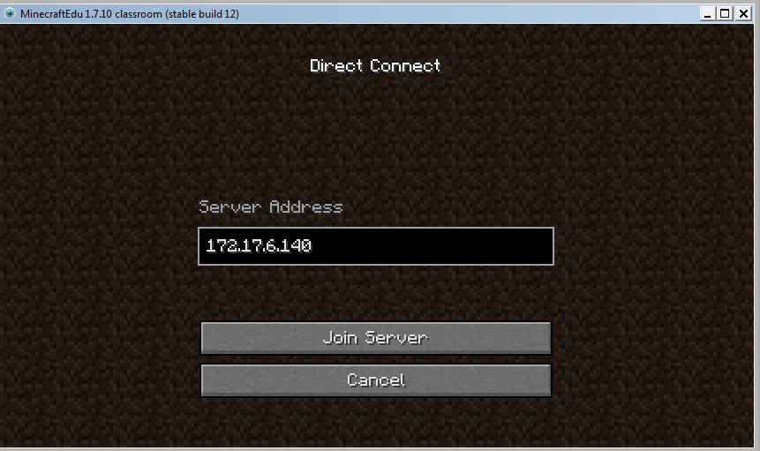

Once you have joined, begin building your city.

These are the basic controls to move around and select blocks for building.

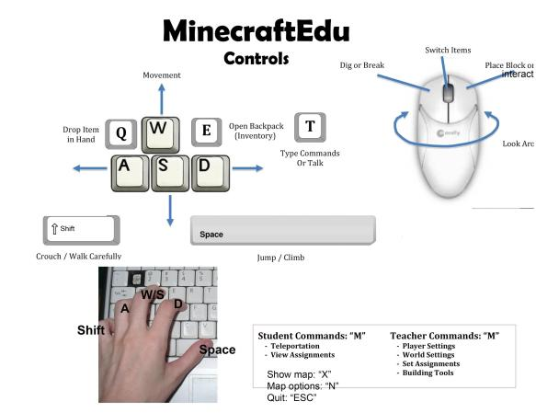

As a teacher, you can fly around the world to monitor students’ progress.

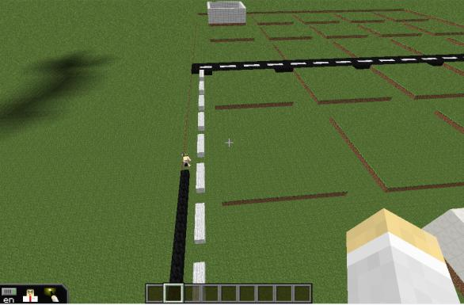

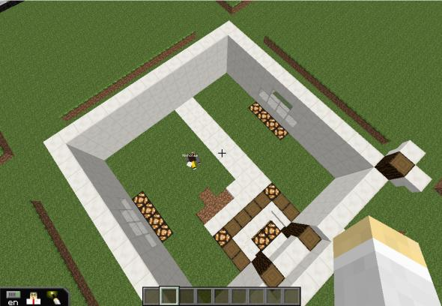

Before quitting Minecraft and closing the server, make sure that you save the Minecraft game from the Minecraft server window.

