Self-Directed Activities: Makey Makey

Activity 1 - Connecting the Makey Makey
The Makey Makey is a circuit board, which will help you to learn more about electricity. A circuit board is an object that carries electricity from one point to another. Because many things like computers and toy cars need power to work, they have circuit boards inside to make sure that the electricity gets to the places where it needs to go.
The Makey Makey is a special type of circuit board because we can easily use it to connect the computer to other objects that conduct electricity. By using the Makey Makey, you will learn about the different parts of a circuit (the power source, wires, input and output) and how the circuit interacts with the computer.
Begin by watching this video of the Makey Makey in action. Then follow these steps to connect the Makey Makey to a computer:
Step 1: Plug in USB
Small side of USB cable plugs into Makey Makey, big side plugs into computer.
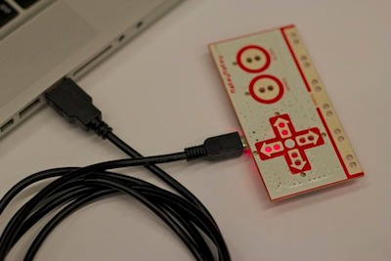
Step 2: Connect to Earth
Connect one end of an alligator clip to "Earth" on the bottom of the front side of MaKey MaKey.
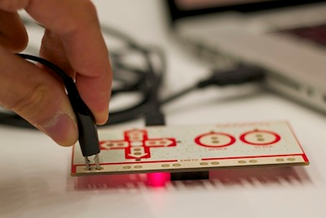
Step 3: Connect to Yourself
Hold the metal part of the other end of the alligator clip between your fingers. You are now "grounded."
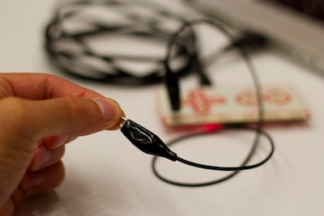
Step 4: Play some MaKey MaKey drums!
While you're still grounded, have open the drums website, and demonstrate playing the drums using the Makey Makeys. Invite a volunteer to be part of your circuit and demonstrate how, by touching the volunteer's nose, you can still play the drums.
Activity 2 – Use the Makey Makey as a controller
Once connected, try the following online activities to explore how the Makey Makey works:
Bongos
Piano
Super Mario Game
As an extension, experiment with using fruits or vegetables. Explore how different foods can be used as controllers.

