Self-Directed Activities: Digital Art

For these activities, you will need a software like ArtRage Lite.

Activity 1 - Develop skills to use a digital tablet for drawing

Digital drawing tablets are designed to replace the use of a mouse for drawing. For this activity, you will be creating a digital portrait. Begin by watching this video to get started.

You can also use a photo as a stencil, e.g.
https://upload.wikimedia.org/wikipedia/commons/f/f1/BarackObamaportrait.jpg

Select the ‘Tracing’ button and insert an image to stencil.

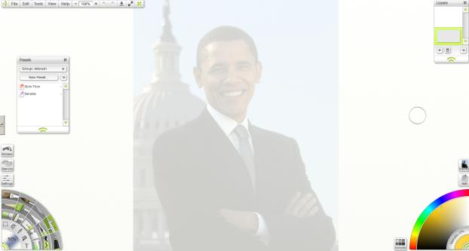

Following the suggestions made in the video, experiment with the digital tablet to create a portrait.

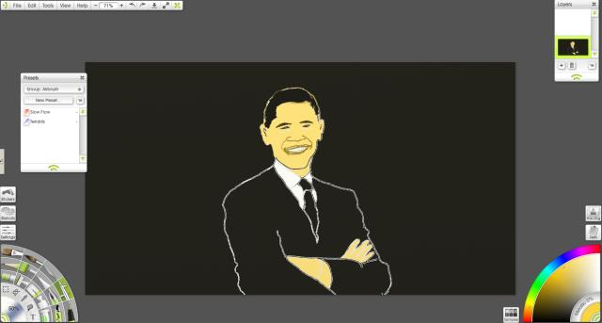

Activity 2 - Use a digital tablet to design a cityscape

Begin by looking at some different examples of cityscapes:

London
https://uaem2015london.files.wordpress.com/2015/01/panoramic_cityscapes4.jpg

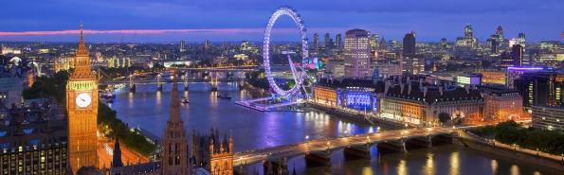
Rio
https://images3.alphacoders.com/230/230357.jpg

Shanghai
https://userscontent2.emaze.com/images/47bc94df-1b3b-4f90-b58b-f51259277402/b607278620a3a03b1b64677d3cefb468.jpg

This video shows how to draw cityscapes.

As in the previous activity, you can insert a cityscape image to trace by clicking on the tracing button.

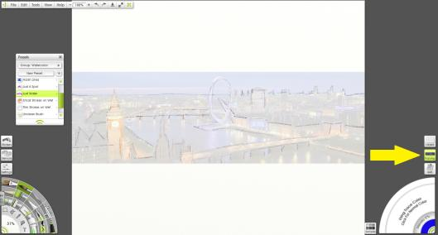

When you have finished tracing, right click on the tracing button, and click clear tracing image. Once this is done, you can focus on the painting of your cityscape.

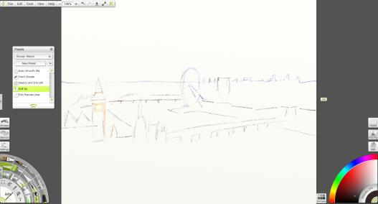

Experiment with the watercolour brush, and select the “unclean brush” preset.

