Scratch Game Plan

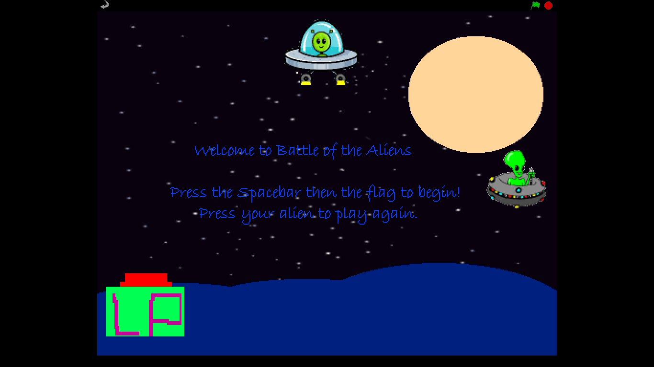
On the document scratch I have created a game for 7-14 year olds called Battle of the Aliens.
This game features two aliens and a landing platform, the aim of the game is to get the top alien safely on the platform. Without being hit by the evil alien at the side.

Design Plan
- My background is spaced themed as that is where the battle of the aliens is held and it suited my tactics and ideas for my game.
- I have a Space Themed Song playing throughout the game called TECHNO 1 it features a Space themed music which suites the overall look of the game.
- I have 3 moving sprites each with different scripts. I have a written sprite as well to inform the player of the controls to play the game.

- Sprite 1 has the ability to move forwards, backwards, left and right to avoid the evil space ship and aim for the landing platform.
- To win the game you have to land on the platform without colliding with the other alien. When you touch the red platform a notification informs you of your winning.
- If you touch the evil alien (Sprite 2) a new costume appears which is your alien exploding also it alerts you of your losing.

Implementation
- In this screen shot I am using the skill to edit my sprites with text, colour and shapes.
- I made this sprite by finding a suitable image on Google then pasting onto scratch and editing out all the unnecessary features.
- In these two screen shots I have used the skill of detail and the ability to generate the needed fragments of a game.
- I don’t have any lives or score because the only aim of my game is to complete the mission given.
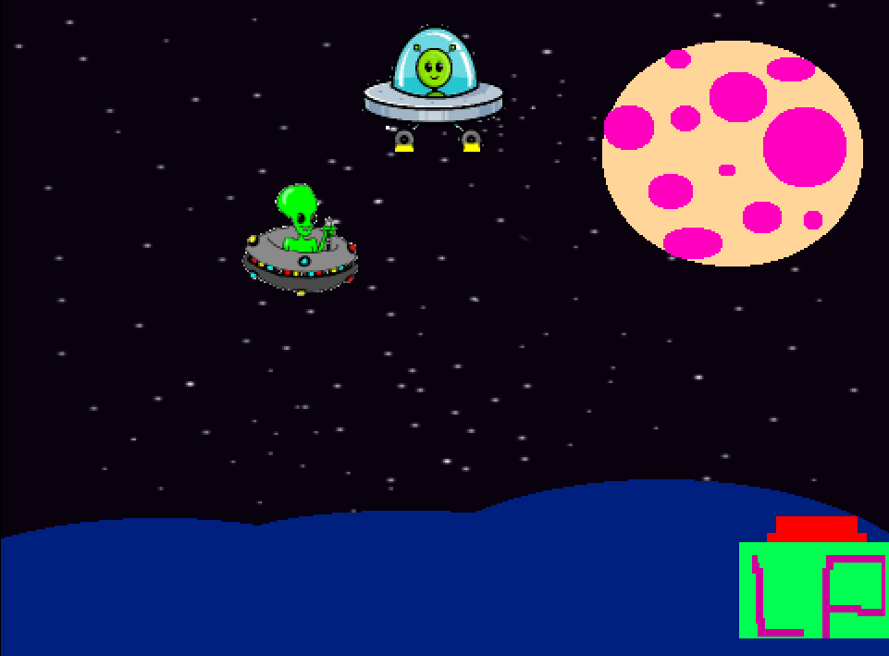
Tested

- After simple parts of the sprites jobs were constructed I began to test the game to find out what I needed to improve after a week I had completed all of my sprites script. Continuing this I added sound and more artistic detail and more costumes indicating that you had won or lost.
- Firstly my evil alien was moving too quickly making it impossible to win also the landing platform was drifting side to side but not in a straight enough line. After I had corrected both of these I had to make sure a player was able to play the game without help from me. So I decided to add a screen title telling the player what to do. My music was also a struggle but after I programmed it to play when the alien spawned for a new game to repeat the song it worked how I wanted it to.

Evaluation Project
- I have learnt many skills mostly small details as how to computerise simple instructions as move up, down and side to side. Also I have learnt how to customise and evolve other people’s designs to fit the type of game I was creating.

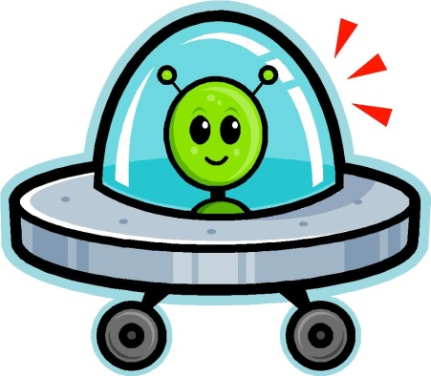

- I believe that the programing went well as the game functions as I hoped with easy instructions that indicate just how to play without guidance from me. The designing also went well as shown above the background of my game is simple but completely suits the category of my game as well as being very characteristic.

Instructions
These are the controls to play my game.
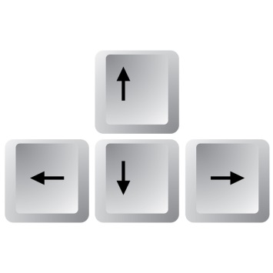
To start the game you press the flag icon which makes the evil alien and landing pod move across the screen. To control your Alien and avoid the evil alien you use the arrow keys. The up arrow makes the alien go up, down arrow is down, left makes the alien go left and right makes it go right. By pressing the good alien icon you get to play again.
I would make variables in my game to make the mission harder to evolve my game even more. Also I would have more obstacles and maybe levels so the player wouldn’t be bored. I would ask for the players name so if they lost I could say hard luck Safaa or congratulations Amy. Also the players could choose the space ship or Alien they want to play with.

