Raspberry Pi Activity 4
Learning Objective: Use Python to create an Adventure Game
For this session, you will use Python. The Python code language is used by millions of developers worldwide, including developers at organisations like NASA, Google and CERN.
You will be using concepts such as using a sequence of instructions to make something happen, loops, conditionals and variables – concepts which are common throughout all programming languages.
Task 1. Use a Text Editor to create a code file. To do this, open up the Python programming environment, IDLE. Then click File from the menu at the top and select New Window to open an untitled text file. Notice that this creates a new text editor file in which you can type all your code and save it, before you test that it works by running IDLE.
Save the file as Inventory. Then type the following:
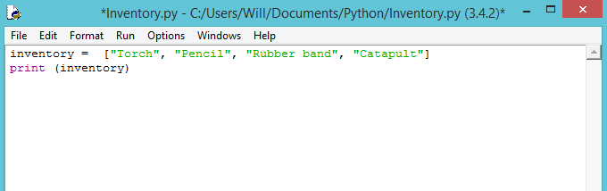
Each piece of text data in quotation marks (called a string) represents an item on the inventory list.
Click Run, then Run Module. Your inventory list will be printed to the IDLE window.
Now adapt the last line of code to read:
print(inventory [3])
Observe what happens. Why do you think it printed Catapult and not Rubber band? Clue: it is to do with the way that Python numbers items in a list.

Task 2. Use the Python time and random modules
Python has a large number of modules – useful blocks of code that you can reuse to avoid having to rewrite the same code over and over each time you need a program that performs the same task.
In order to use a module within a Python program, you use the Python word import followed by the name of the module. As you write the code, you will include comments.
Comments are notes within your code that explain what a line or section of code is intended to do. Each comment line begins with a #symbol, which tells the computer running the program to ignore that line. Comments help you remember what each line of code is doing, and they help others see what you have already done.
With the Inventory.py file that you created earlier, type the following code:
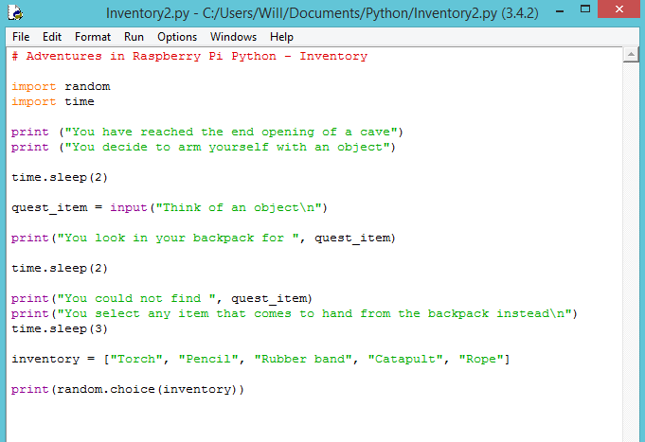
Note: the \n at the end of the string for quest_item input makes an extra new line below, which makes the text easier to read.
Challenge: As the code is written at the moment, when the user inputs an item from the inventory list, e.g. torch, the program will print that the item could not be found. Can you think of a way to improve the program so that it checks to see if the item is already in the list?

Solution to challenge from task 2:

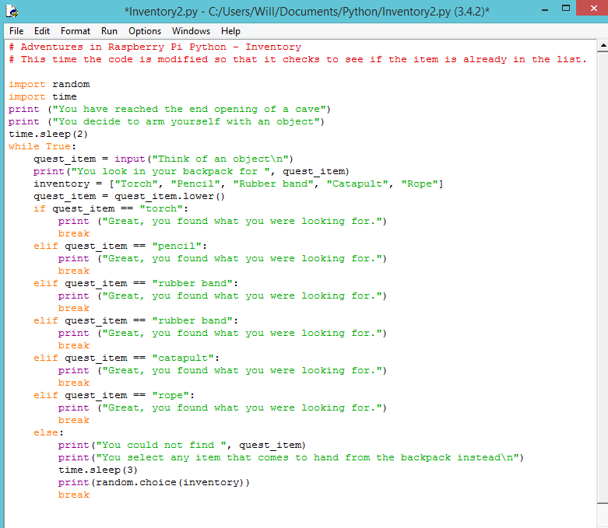

Task 3. For this task you will create a Python Text Adventure Game that uses text to direct the player through the game. The program will ask the player to make decisions on what to do next.
As the text adventure game relies on the player (user) to interact with the game to make decisions, you will need to use the input() function. This line of code asks the player to answer a question, and the program will wait for the player to type an acceptable response – one that the program will understand.
The while True: condition will loop the question over and over until the Player enters either left or right so that the game does not end if the player types anything else.
Remember: Indentation refers to how far from the margin line a code is typed. Indentation of code in Python is very important, especially when you begin to add more structure to the code by using conditionals and loops.

Now that you have learned a little about the input function and while True condition, type the following code:
Using conditionals in a Python adventure game
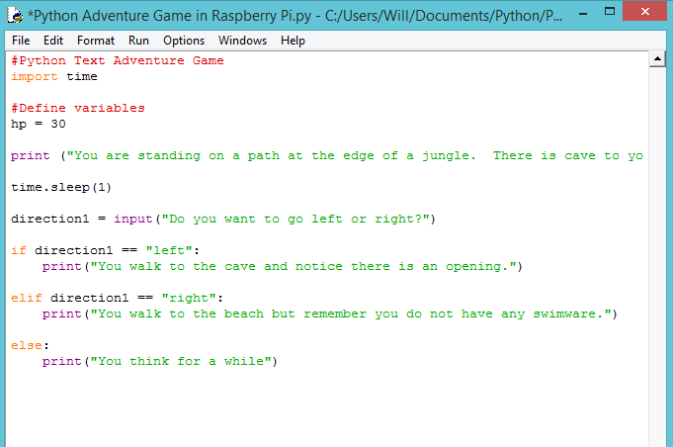
Here, you have used conditionals in the Python adventure game. Now, to make sure that the player types in the correct lower case response that you require to meet the conditions, you can use a lower case function so that if the player types in capital letters, the program will turn the text into lower case, which is a recognised response to the if, elif, and else conditions.
direction1 = direction1.lower()
Add this line before the first if statement used, and after asking the player to input a direction.

Adding direction1 = direction1.lower()
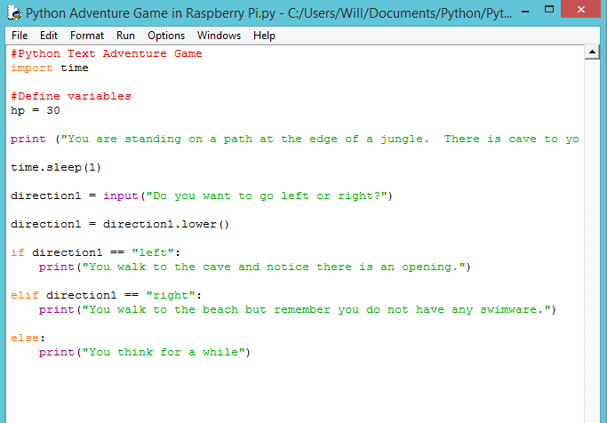

Using a while loop in the adventure game
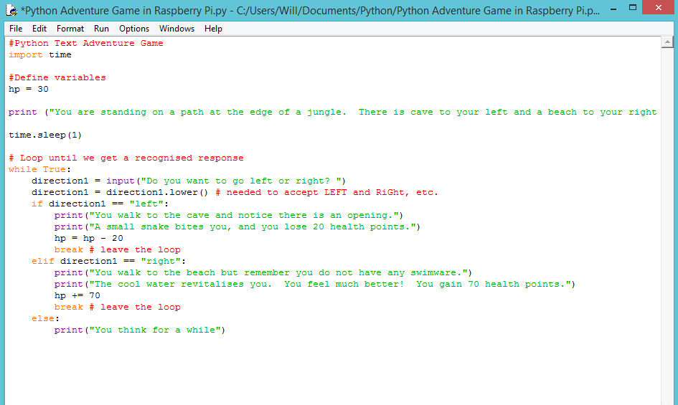
Now, put all the elements together of the text adventure game by typing the following program:
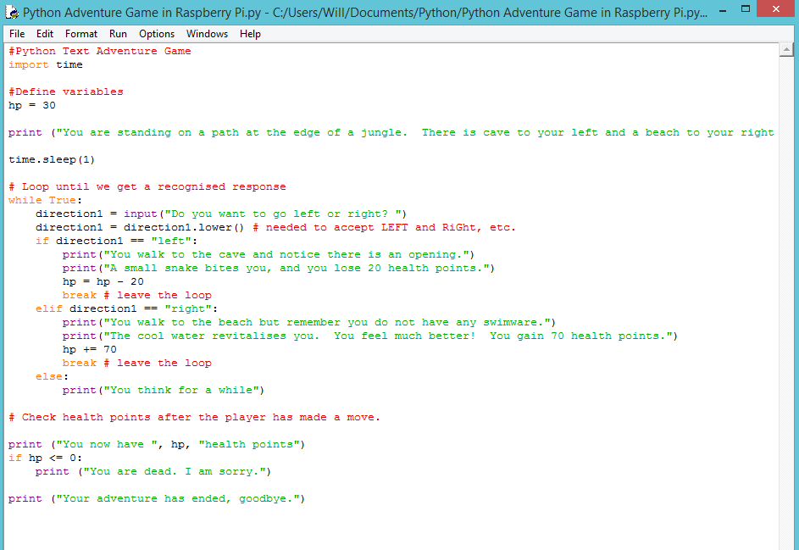

Task 4. At this stage you will do a process called refactoring – a way of restructuring code you have already written to make it more efficient and easy to read, and to avoid bugs. One way of doing this is to use two functions: get_input() and handle_room().
The get_input function will keep on asking the payer to enter inputs until it matches one of the accepted inputs (in this case, the accepted inputs are left or right).
Up to this point, you wrote all of your game logic in the while loop. With the following code, you move most of the logic into separate functions, avoiding repetitive code. The new loop calls the handle_room() function to perform a task appropriate for the current room, and then updates the location variable with the new room. This more advanced code will require you to check and double-check that your indentation is correct and you have not made any syntax errors.
Open a new text editor window and save as AdventureGame2.py. Follow the steps on the next page to add functions to your adventure game.
Note: Remember to indent your code correctly here, as three levels of indentation are being used.

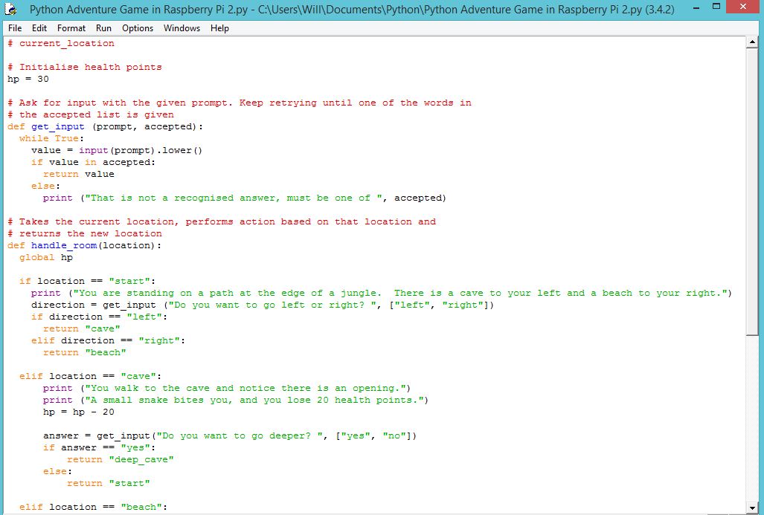
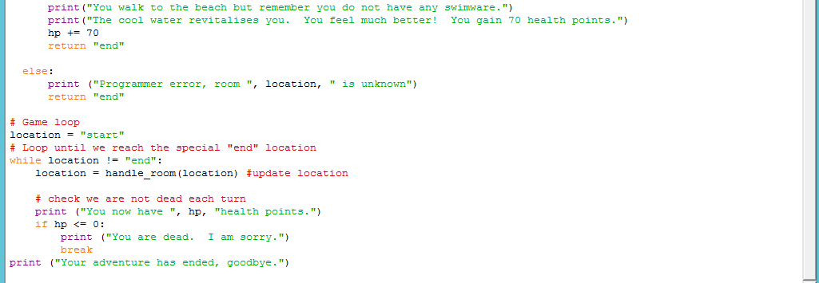

Finally, test that you game works, checking for any bugs.

