WALT: Create a program that has a conversation with the user
Once children have completed the previous Python lessons, including the coding challenges, it is intended that they have the opportunity to reinforce the skills and knowledge covered.
Show the children an example using a video clip of Dave’s conversation with Hal from the famous sci-fi film, Space Odyssey 2001.
https://www.youtube.com/watch?v=ARJ8cAGm6JE
Once children have watched the video, explain that they will be writing a program that appears to transform their computer into an ‘intelligent robot’ which may have a conversation with you - but a more obedient computer than Hal was!
Get the Python IDLE ready with the PythonAI_test file open, which will run the code below:
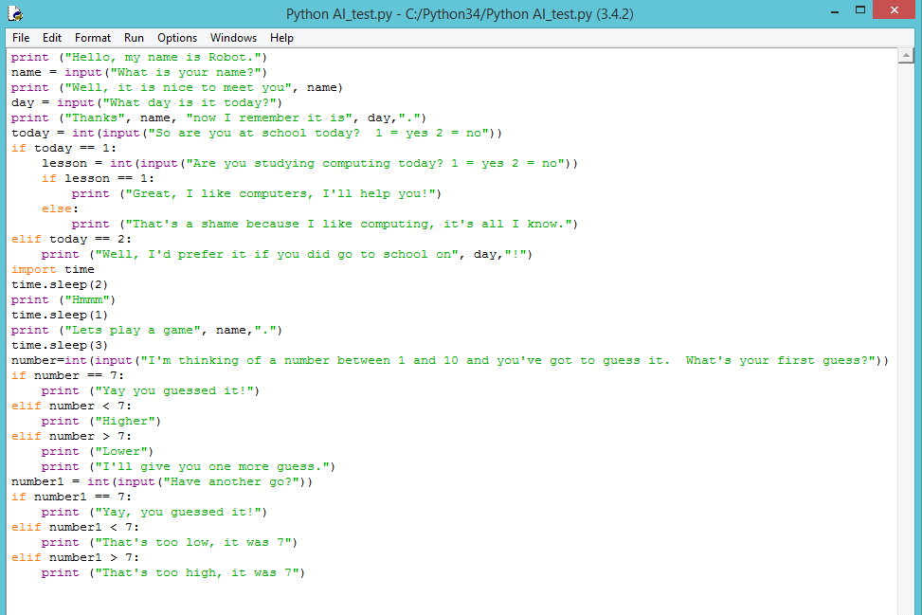

Ask a volunteer to come to the front to answer the computer’s questions.
Explain to children that in order to make this program so that it appears the computer is having a conversation with us, we have used a series of inputs and selection algorithms. Project the code used in the Python Editor and go over a couple of examples by changing the code.
Remind the children of variables – in this case, ‘name’, ‘day’, ‘today’, ‘lesson’ and ‘number’. Explain that we have declared these variables but instead of assigning them values, we have used the input() statements that allow us to write a question to the user. Since we have several options for some of our variables, we have used conditional statements called ‘else if’ (written in code as elif).
Remind the children that a single equals sign (=) is used to declare variables, whereas a double equals sign (==) is used to provide a different response depending on the user’s answer.
We have also used a time.sleep() code to make Python pause before it delivers its next question, which can make the interaction feel more natural.
Independent work:
Using the example of code below, write your own program so that it appears the computer is having a conversation with the user.

