WALT: Use conditional statements if, else if (elif) and else
The concepts covered in this lesson underpin programming computer games as well as simple forms of artificial intelligence.
Explain that we are going to write a short piece of code using conditional statements and comparison operators.
Class demonstration
Use the following code as an example:
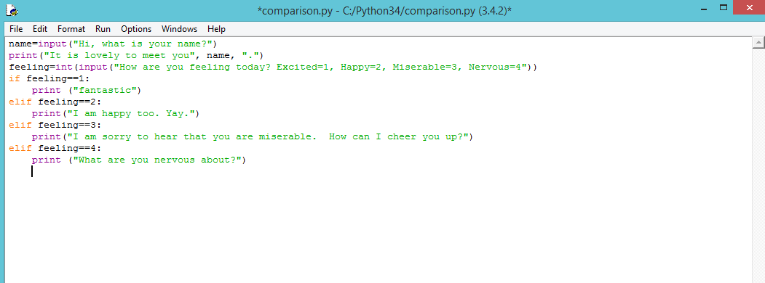
We have declared two variables – name and feeling. Since we have several options in our menu of feelings, we then use another conditional statement called ‘else if’ (written in code as elif). Note that a single equals sign (=) is used to declare variables, whereas a double equals sign (==) is used to provide a different response for the other feelings.

Independent work:
Can you program a Spanish dictionary that provides the user with a range of English words to choose from and returns the translation in Spanish?
Start children off with an example dictionary:
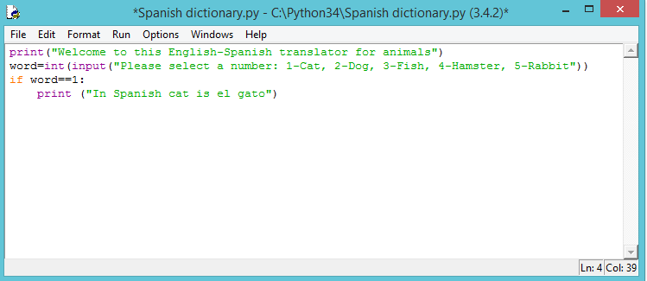
For lower ability children, give them a print out of the full solution to follow.
Solution:
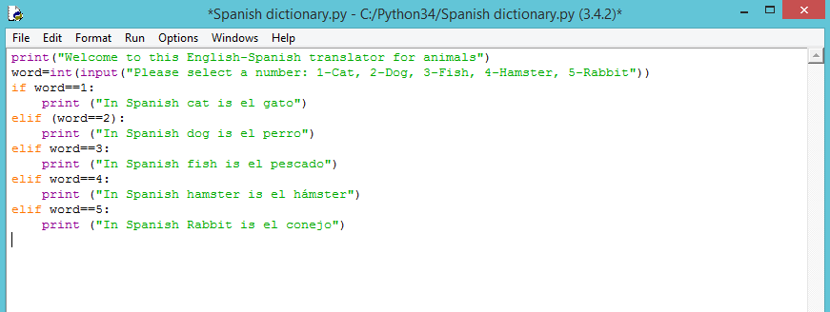

As an extension, children can be asked to complete a different Spanish dictionary or simply add more words to the animal dictionary.

